Ideation Phase
Empathize & Discover

Date | 05 July 2026
Project Name | Cab booking
Maximum Marks | 4 Marks

Empathy Map Canvas – Ucab (Cab Booking System)
👤 USER PERSONA
Name: Rahul Sharma
Age: 26 Years
Occupation: Software Engineer
Location: Hyderabad
Uses: Android Mobile
Goal: Book safe, affordable, and quick cab rides.
🗣️ SAYS
- "I need a cab immediately."
- "I want transparent fare pricing."
- "I prefer secure online payments."
- "I need to know where my driver is."
- "Booking should be simple and fast."
💭 THINKS
- Will I get a cab during peak hours?
- Is the driver trustworthy?
- Is the fare reasonable?
- Can I reach my destination on time?
- Is my payment secure?
❤️ FEELS
- Frustrated when no cabs are available.
- Stressed if the driver is delayed.
- Happy when booking is quick.
- Confident with live tracking.
- Safe when driver details are available.
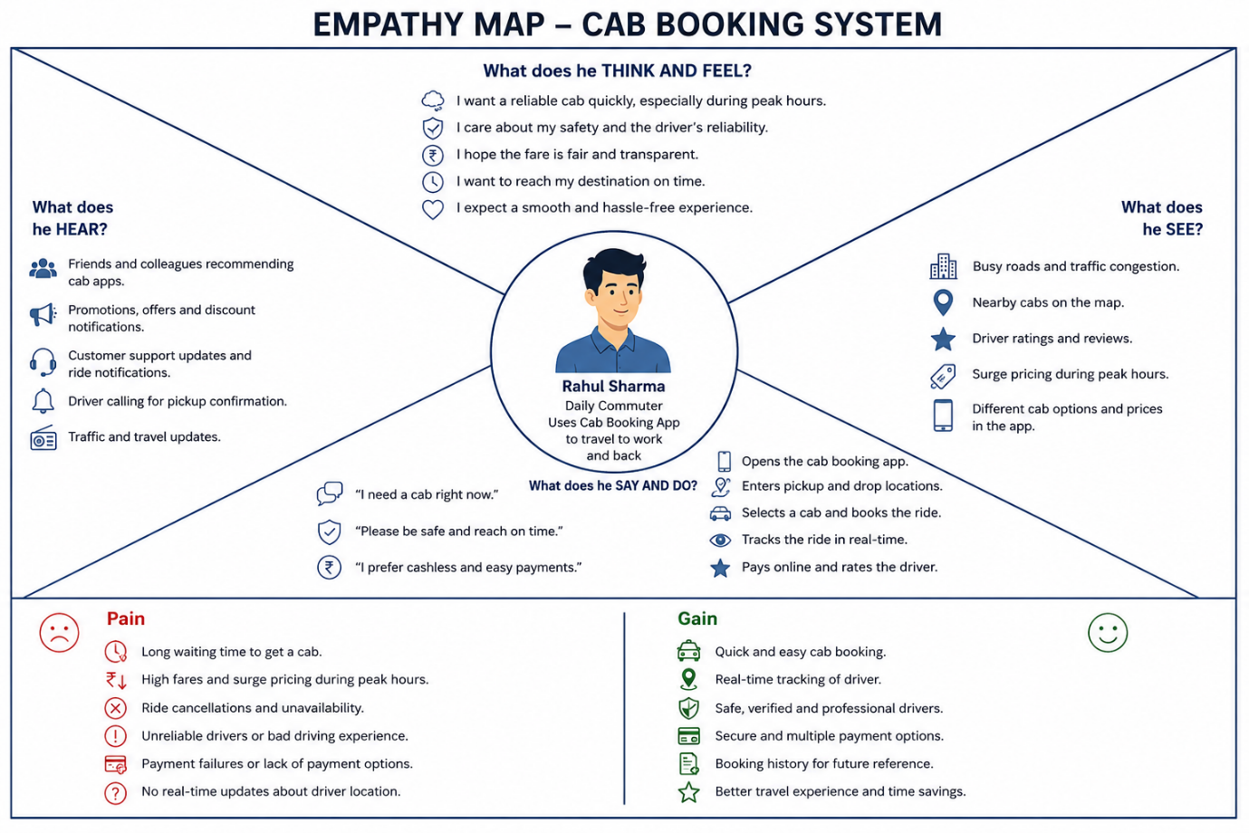

👀 SEES
- Different cab booking apps.
- Surge pricing during busy hours.
- GPS maps showing nearby cabs.
- Driver ratings and reviews.
- Promotional offers and discounts.
👂 HEARS
- Friends recommending ride-sharing apps.
- Notifications about discounts.
- Driver calling for pickup confirmation.
- Customer support updates.
- Traffic alerts.
🚶 DOES
- Opens Ucab app.
- Logs into account.
- Selects pickup and drop locations.
- Chooses cab type.
- Books ride.
- Tracks driver.
- Pays online.
- Rates driver after trip.
😟 PAINS
- Long waiting times.
- High fares during rush hours.
- Ride cancellations.
- Poor driver communication.
- Payment failures.
- Difficulty finding nearby cabs.
🌟 GAINS
- Quick cab booking.
- Live ride tracking.
- Safe and verified drivers.
- Secure online payments.
- Booking history.
- Easy cancellation.
- Better travel experience.
- Time savings.

